DEAR FAMILIES,
WE HOPE THAT YOU ARE CONTINUING TO STAY SAFE AND WELL. PLEASE NOTE THAT THESE ASSIGNMENTS SHOULD BE WORKED ON A LITTLE AT A TIME EACH DAY. PLEASE DO NOT FEEL LIKE YOUR CHILD NEEDS TO WORK ON CLASSWORK ALL DAY. THEY ARE MEANT TO BE HELPFUL, NOT STRESSFUL. THANK YOU FOR ALL THAT YOUR ARE DOING WITH YOUR CHILD AT HOME. WE MISS YOU!
SENDING LOVE,
MRS. PICCIRILLO, MISS AVERSA, MISS EVERTS, & MRS. JONES

ASSIGNMENTS! (5/11-5/15)

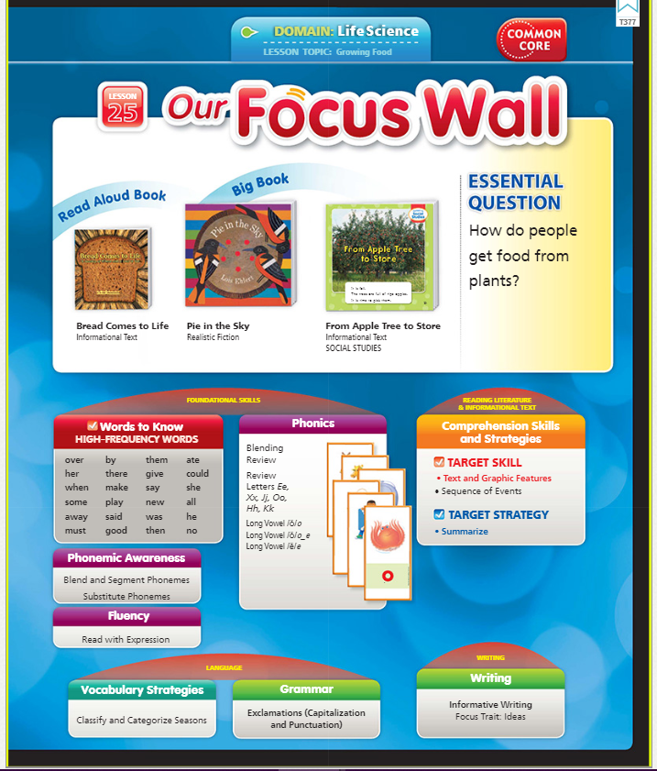

TOPIC- Growing Food

SIGHT WORDS- (review week)

her, when, said, by, them, give, she, all

Read Aloud Book: Bread Comes to Life

Listen here: https://www.youtube.com/watch?v=FkJ3-plxswM

Big Book: Pie in the Sky

Listen here: https://www.youtube.com/watch?v=TceUMI4jBpE

ELA-

- Click below to listen to the story online- Bread Comes to Life
https://www.youtube.com/watch?v=FkJ3-plxswM

- Writing- How do people get food from plants?

(EXAMPLE: People can pick apples off an apple tree. They can eat the apples.)

(EXAMPLE of a picture to match: draw a picture of an apple tree.)

- 5 minutes of fun ELA from our ELA page

Sight words- her, when, said, by, them, give, she, all

Suggestions for Sight Words-

Practice writing words, use them in a sentence, do a word hunt in your favorite book, write them on flash cards!

Math-

- Practice writing your numbers 1-30 (& beyond)

- Count out loud to a family member from 1-100

- Complete this Pattern Block sheet

- Complete this Drawing Shape sheet

- Complete this At Home Shape Hunt sheets

- Complete this Color by Addition sheet

FUNdations-

CVC-e long O Video-

https://www.youtube.com/watch?v=SUp-nnGusvk

Practice tapping out, reading, & writing CVC-e words: (Focus on the long /o/ sound)

Vote

Cone

Tone

Home

Note

Pole

Role

- Practice long vowel /O/ words here:

- Do this CVC-e worksheet -

Science-

Make a Rain Gauge!
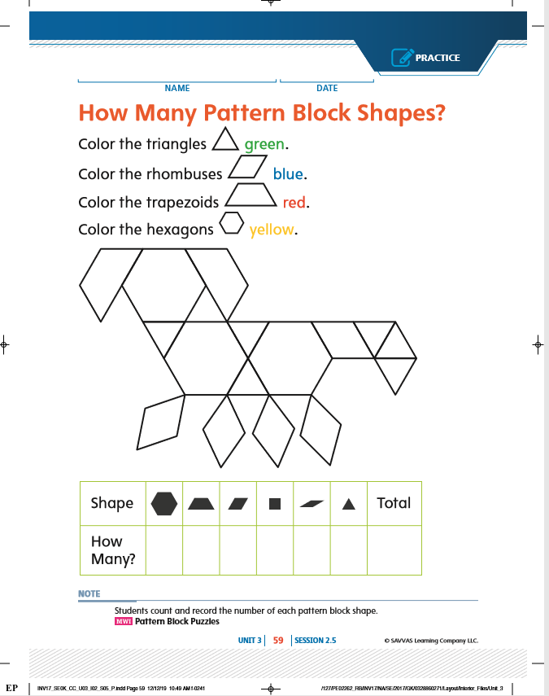

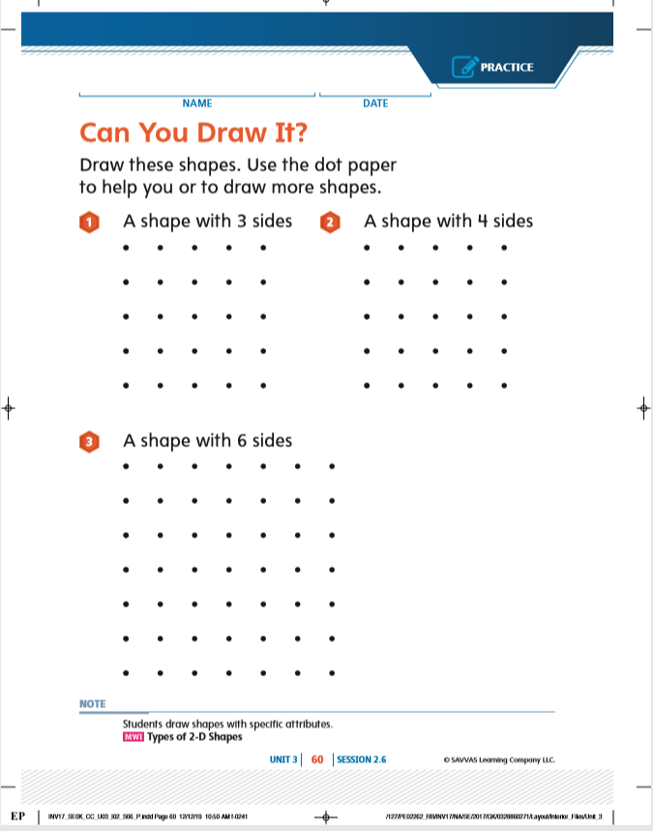

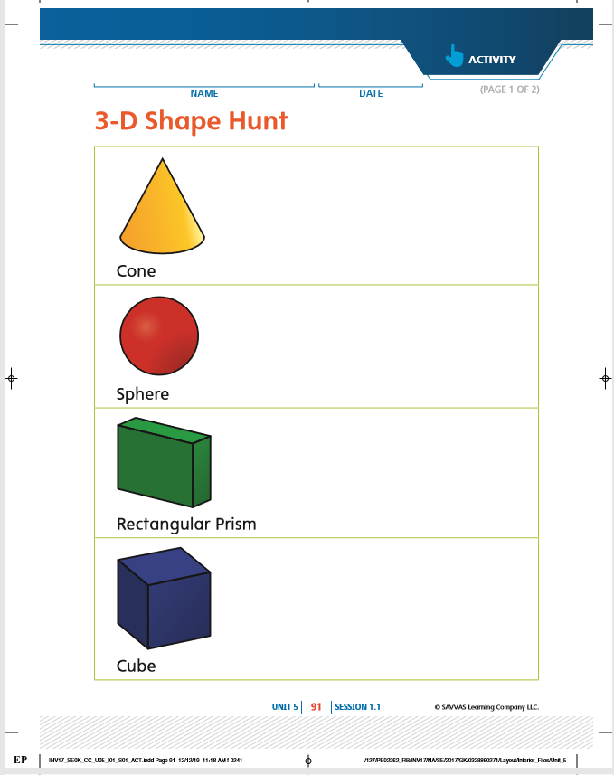

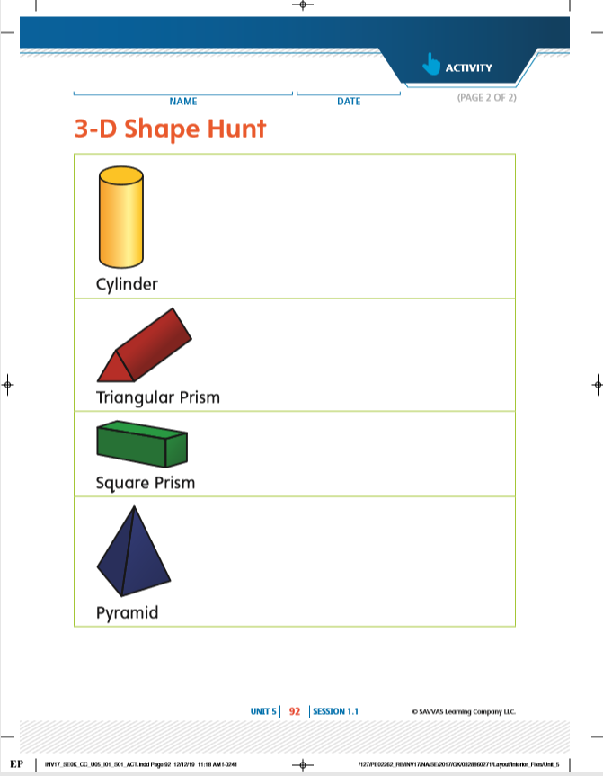

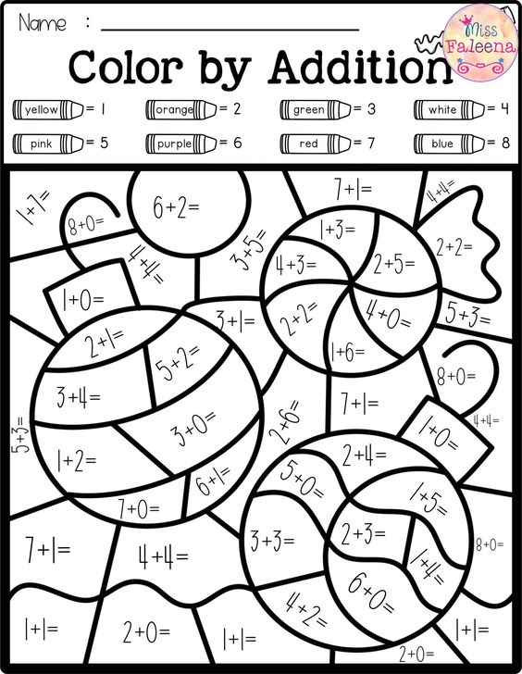

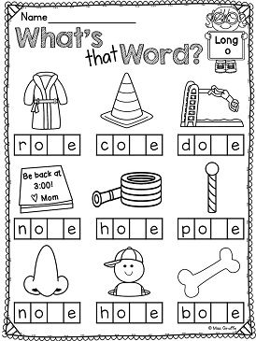

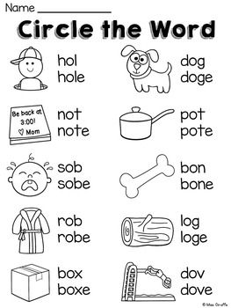

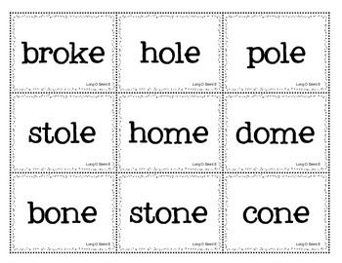

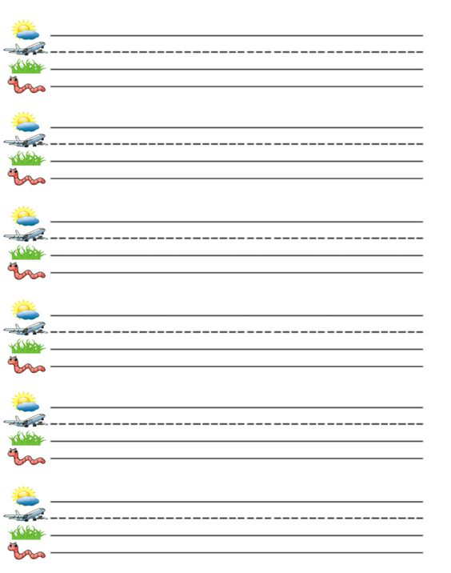

Write your numbers from 0-20
(Keep going if you can!)

0
